*Networks: Definition and Why We Study Them*

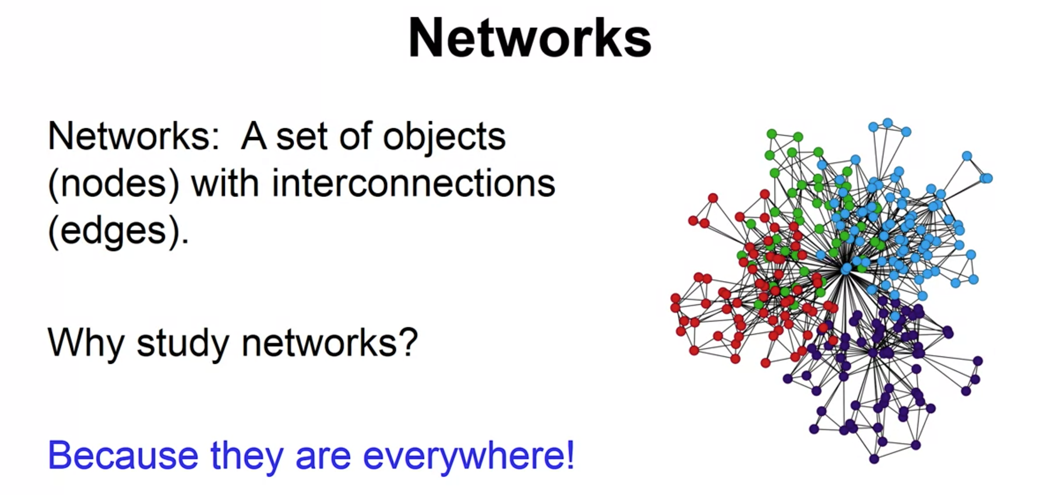

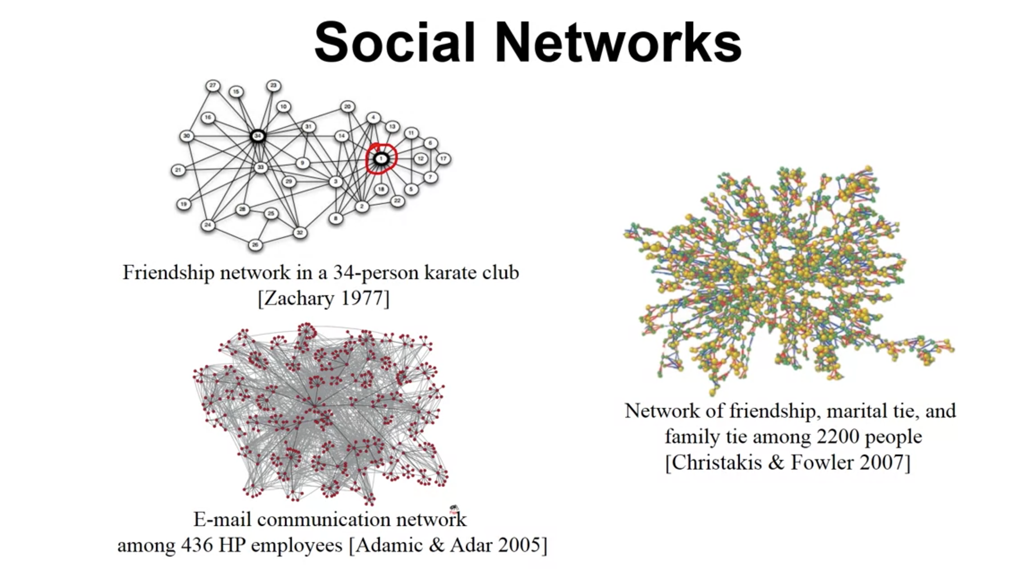

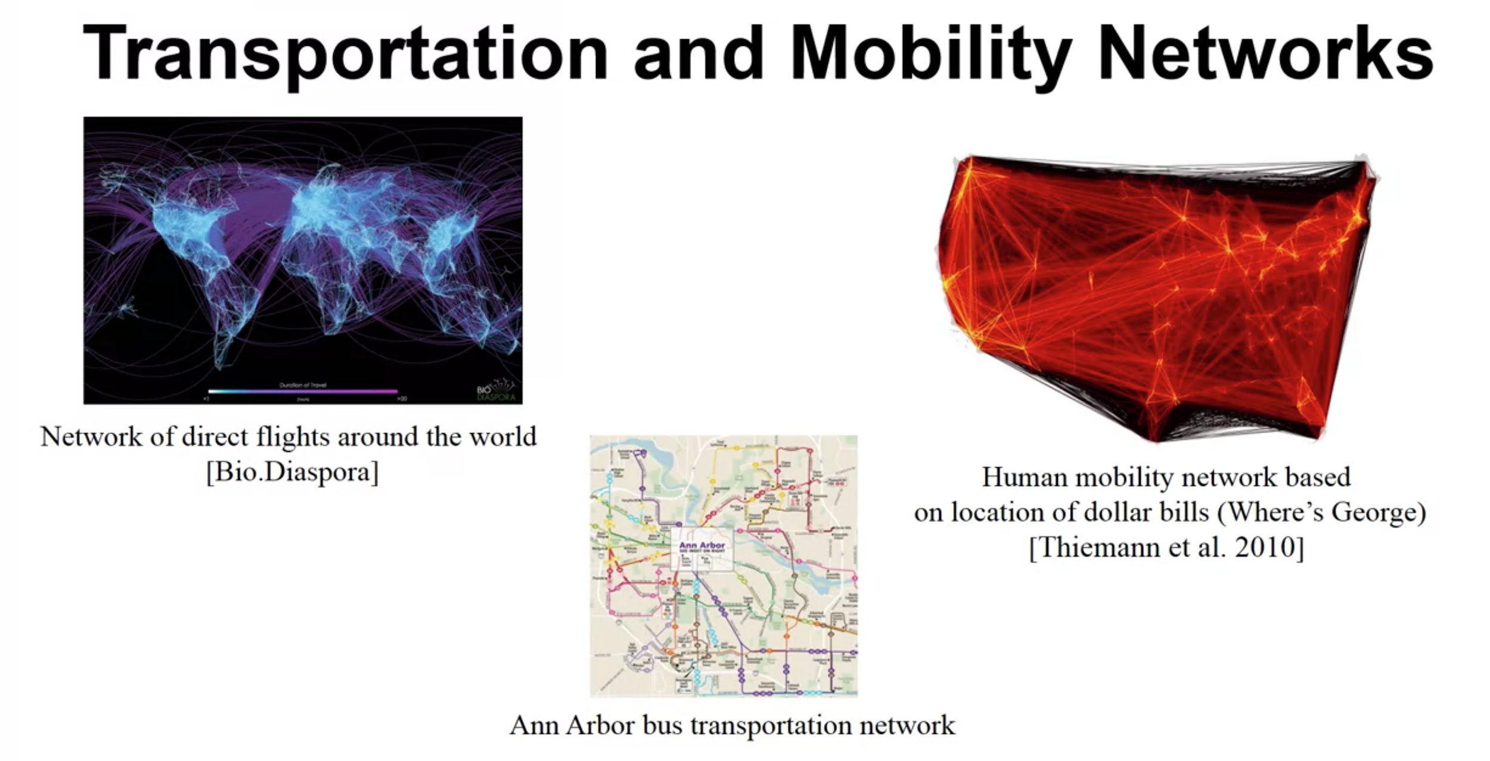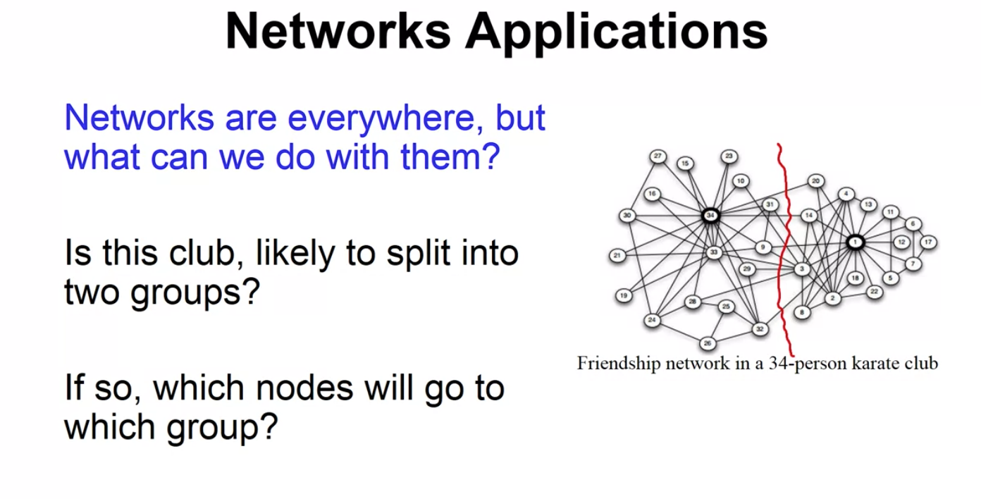

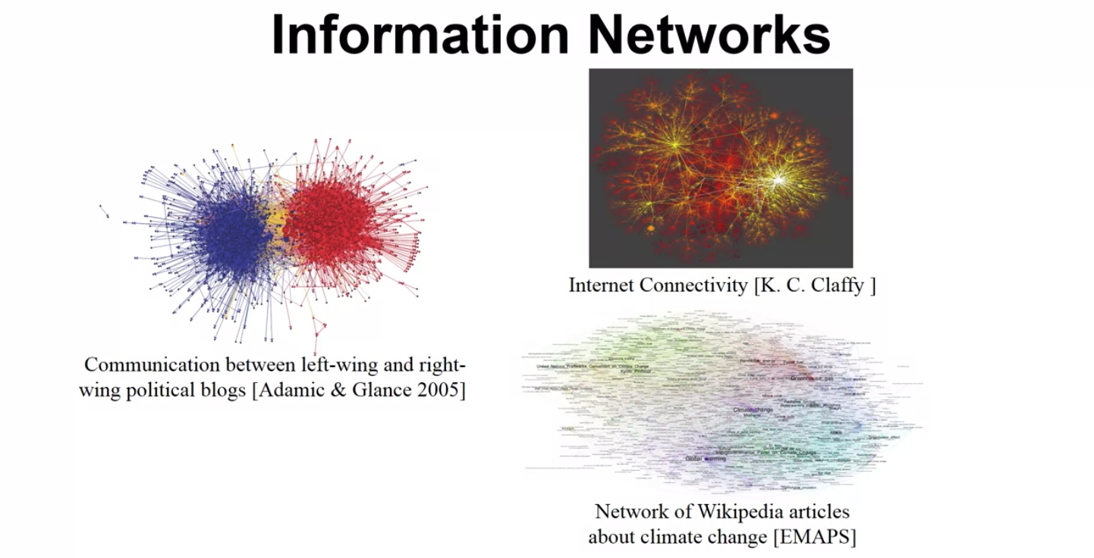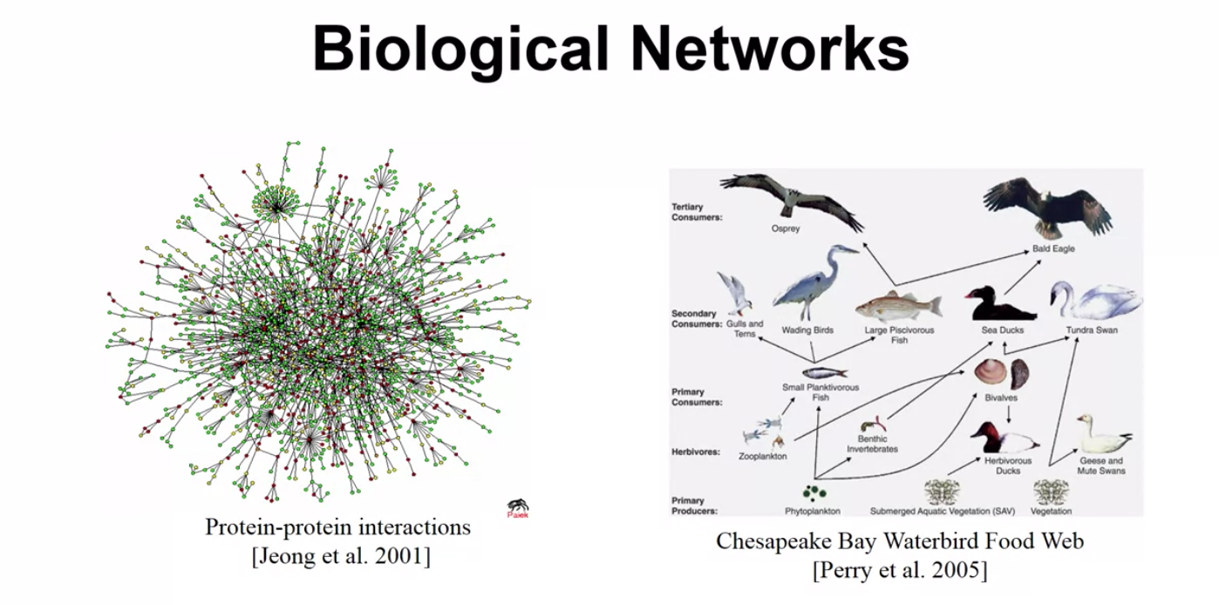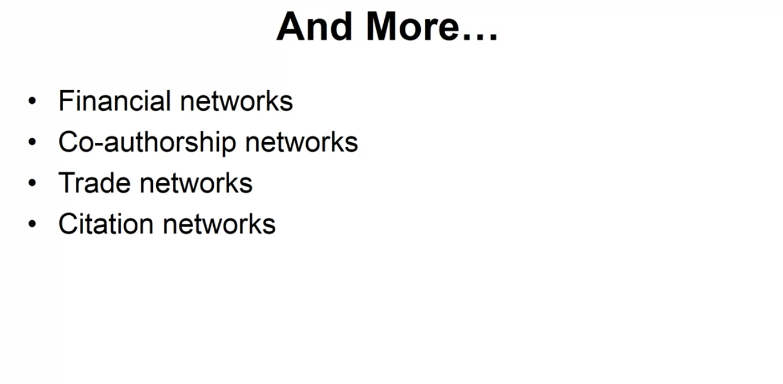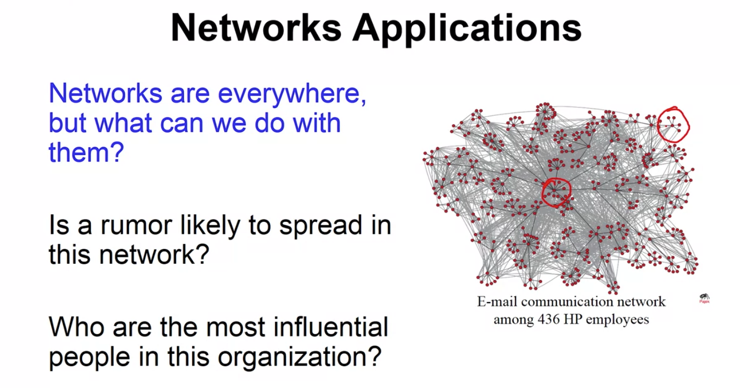



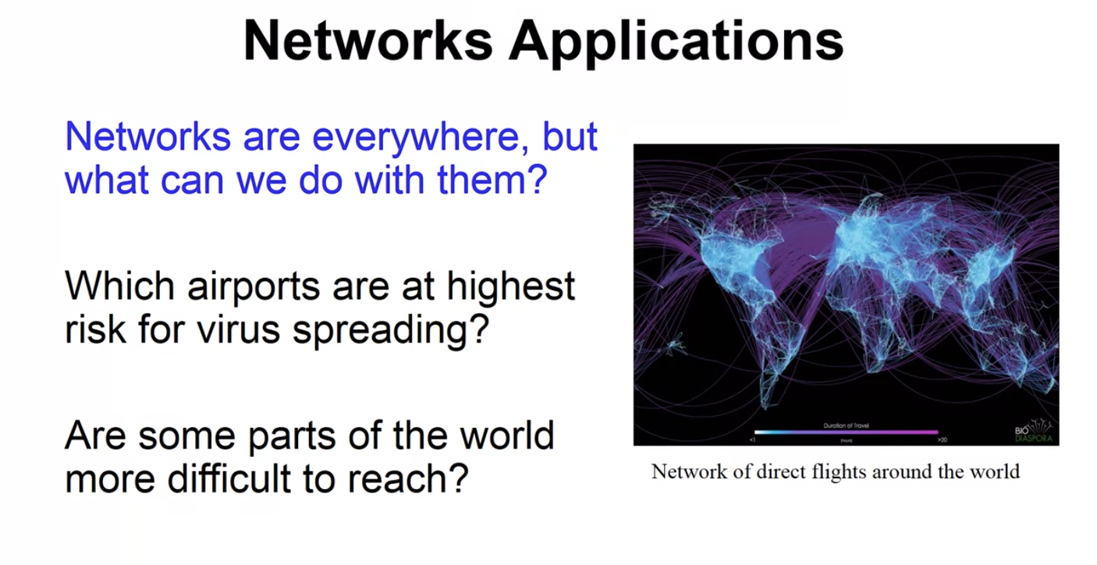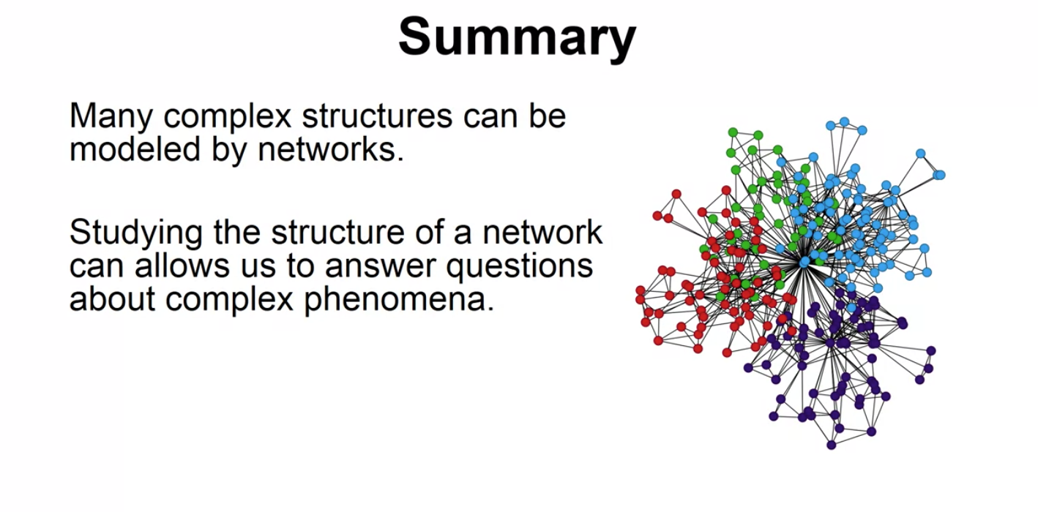

So in summary, many complex structures can be modeled through networks. So we saw examples from social networks, biology networks, transportation networks, and so on.

And by studying the structure of these networks, we can start to answer questions that are pretty complex. And that a deal with very complex relationships and networks allow us to make those relationships, or to make those complex phenomena simpler by representing them as a network and then using certain tools that allow us to answer that. And so, in this course we're going to cover some of the basic techniques to study social networks and answer some very interesting questions about them.

*Network Definition and Vocabulary*

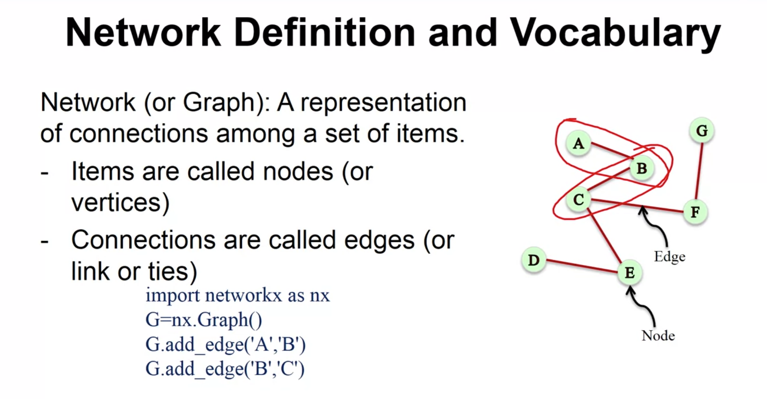

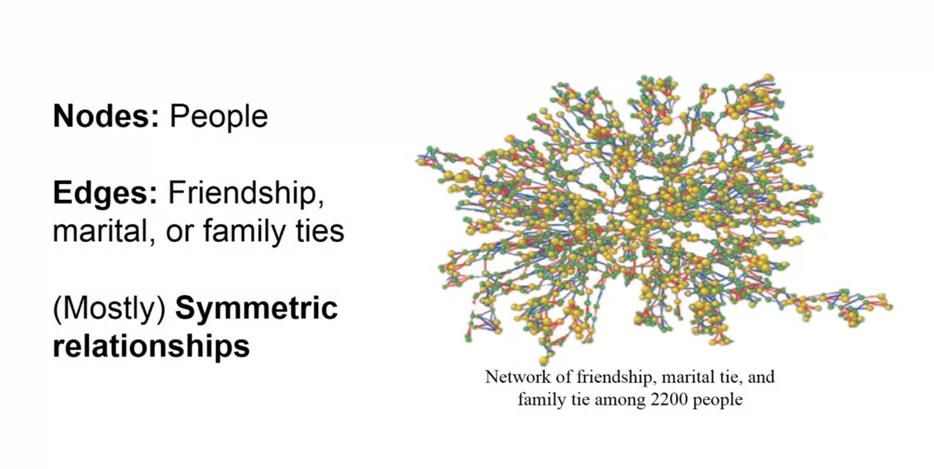

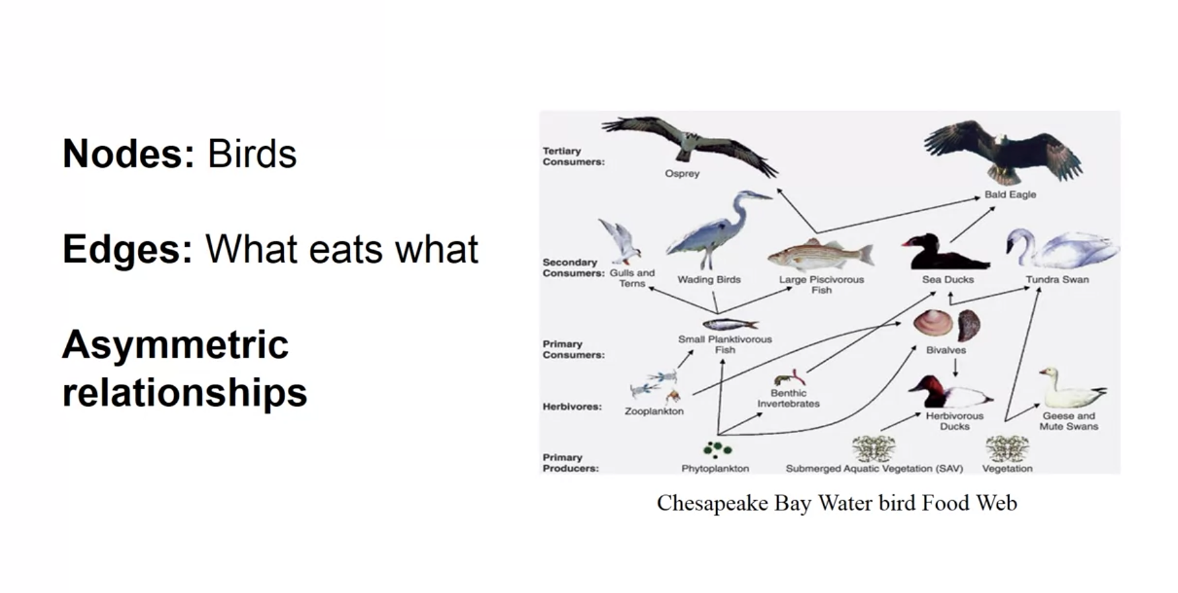

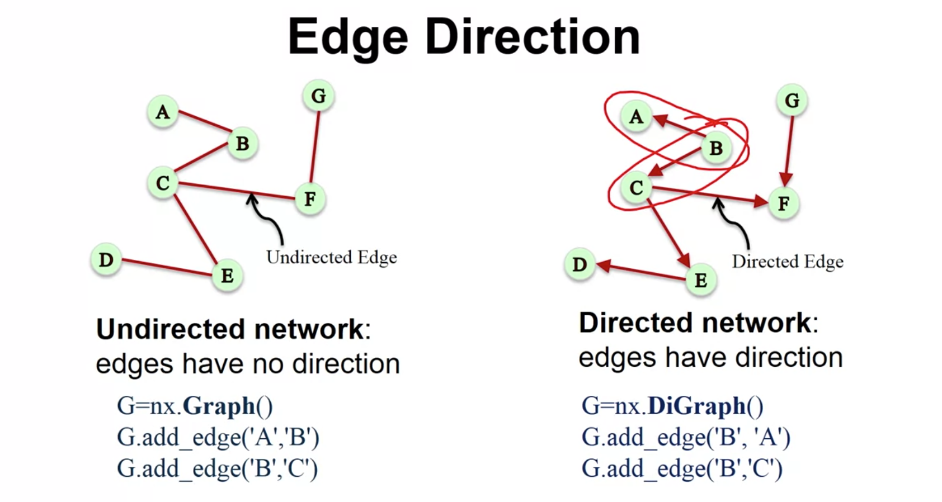

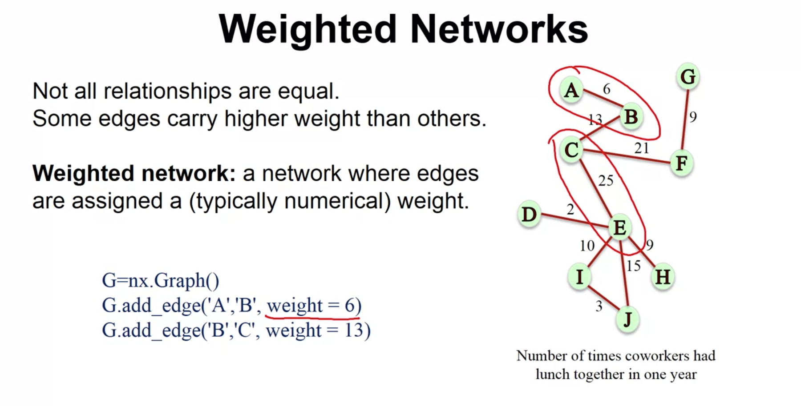

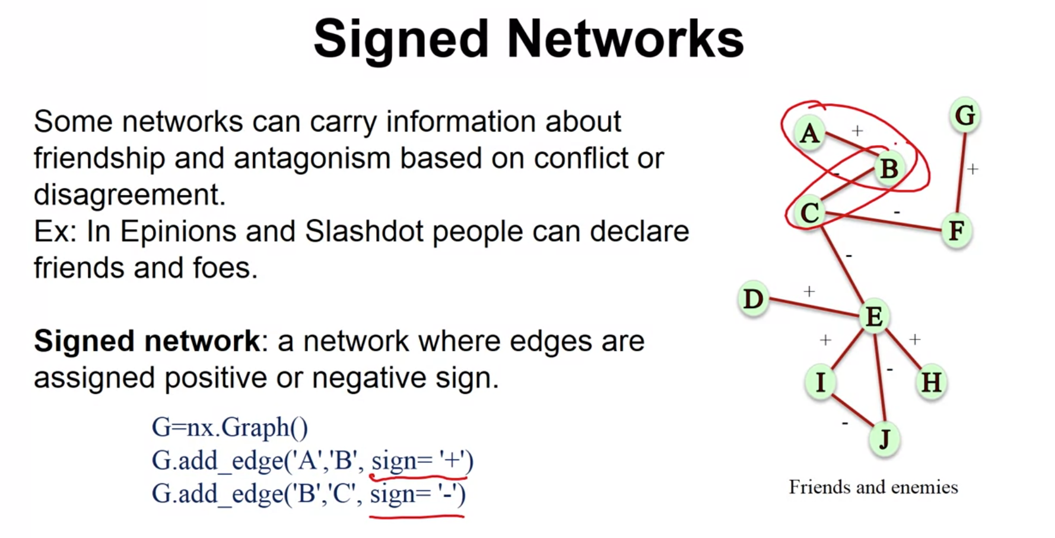

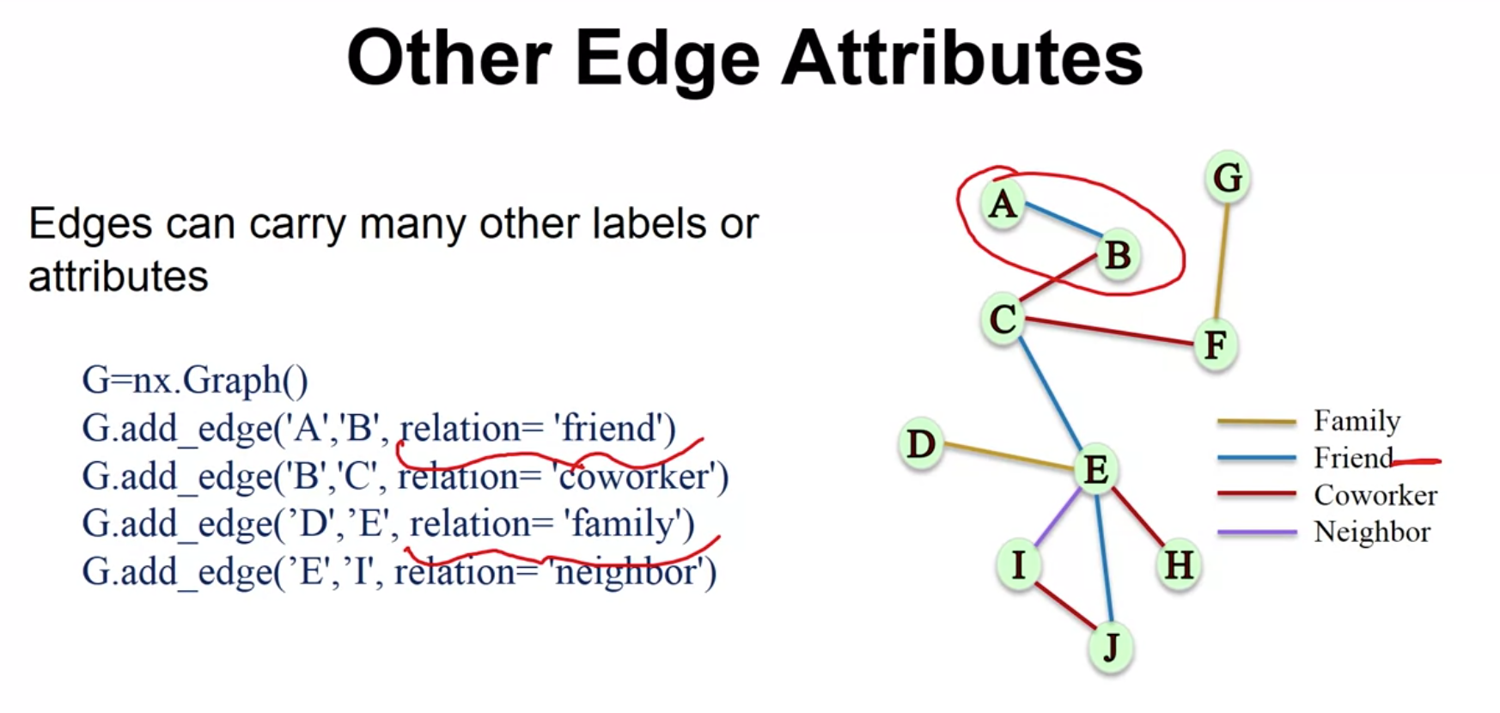

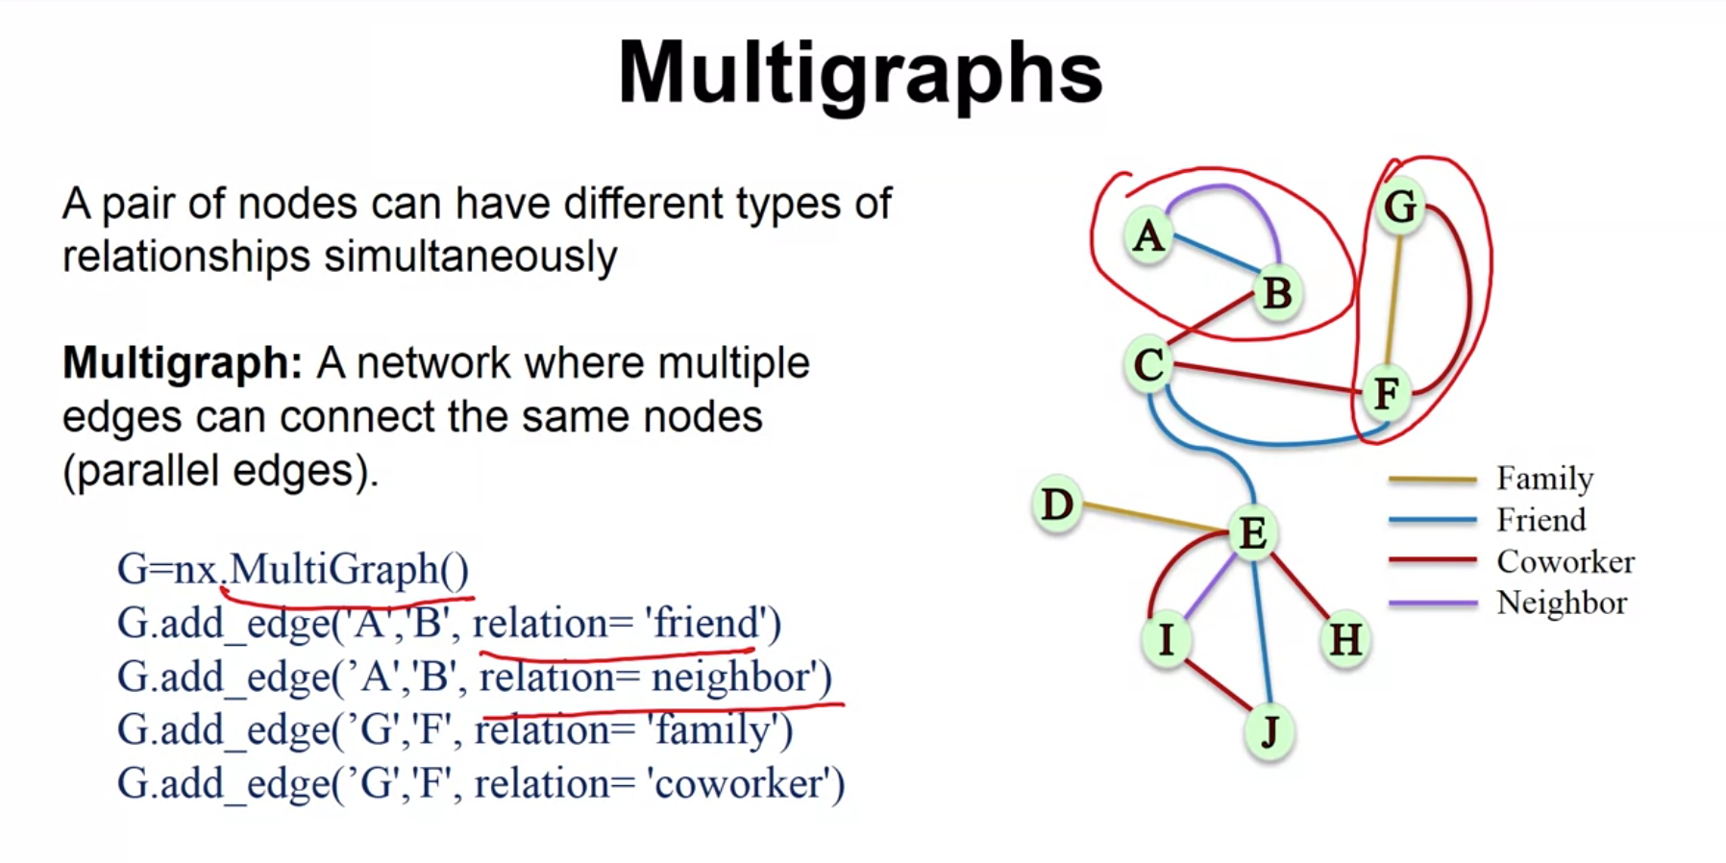

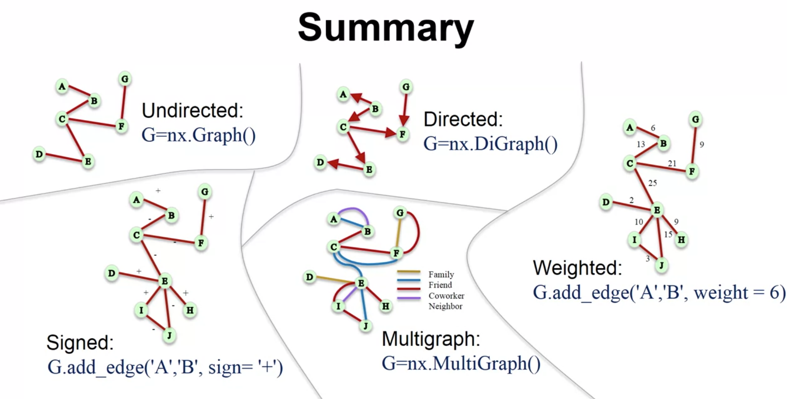

So in summary, what we saw in this video is that we have many different types of networks. We have undirected networks or undirected graphs, which we use the Graph class in order to represent them. We have directed graphs for which we use the DiGraph class. We have sign networks for which we use the Graph class but we assign attributes to the edges when we add them. We have multigraphs, and for those we use the MultiGraph class, and those can handle multiple edges for each pair of notes. And then we have the weighted networks for which we add a weight attribute in the edges when we add the edges.

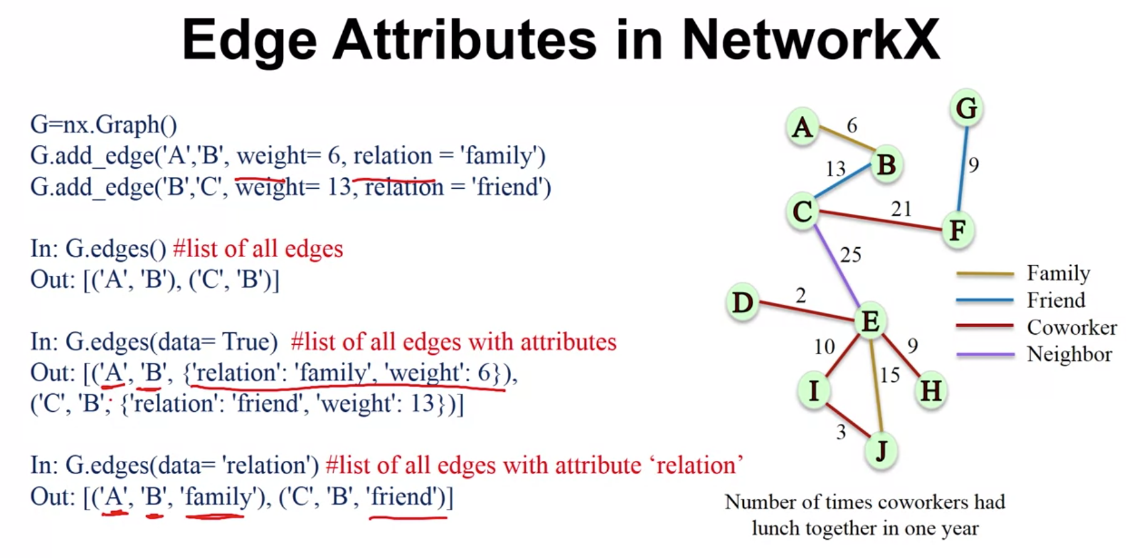

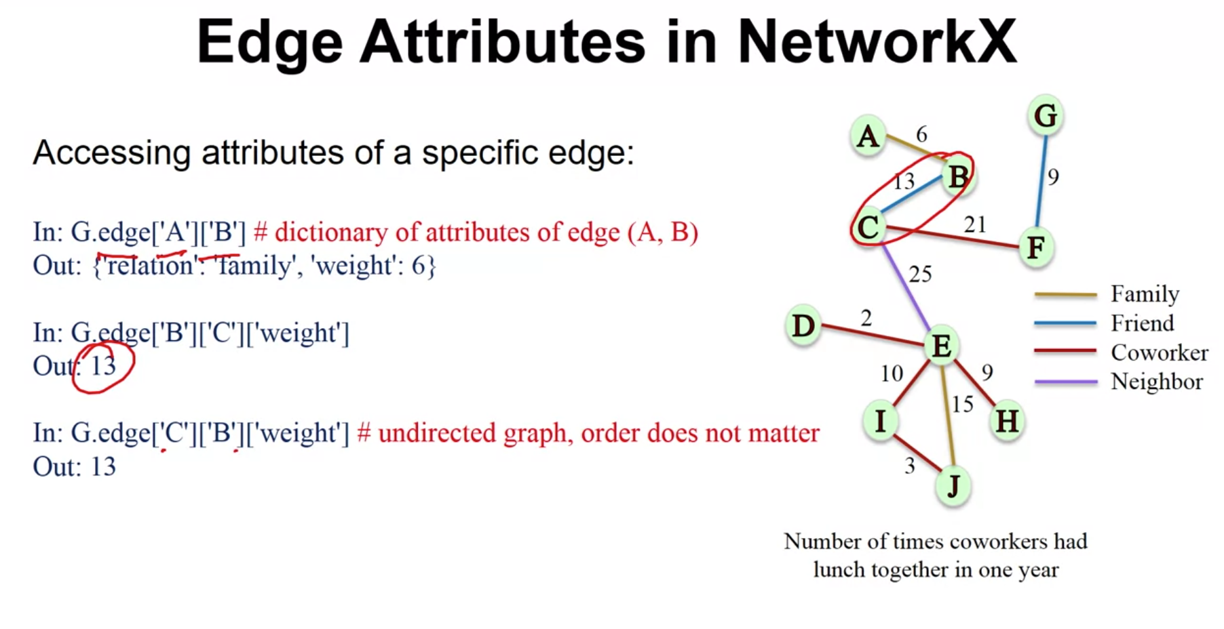

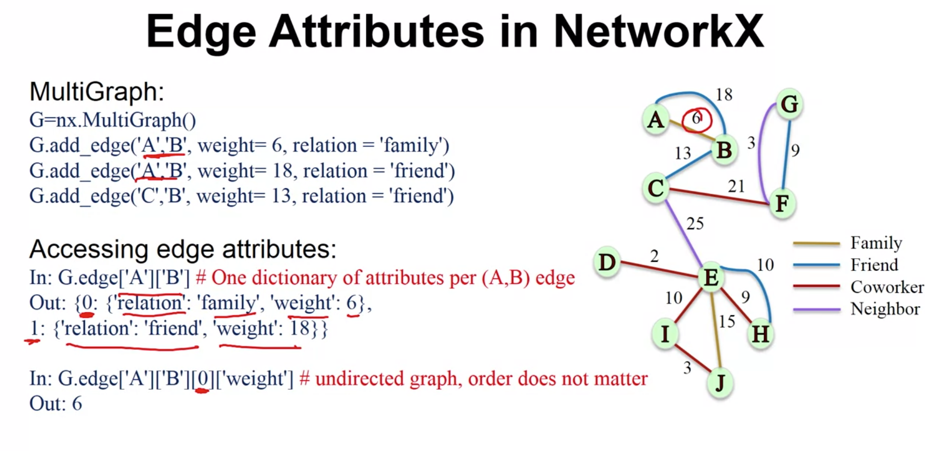

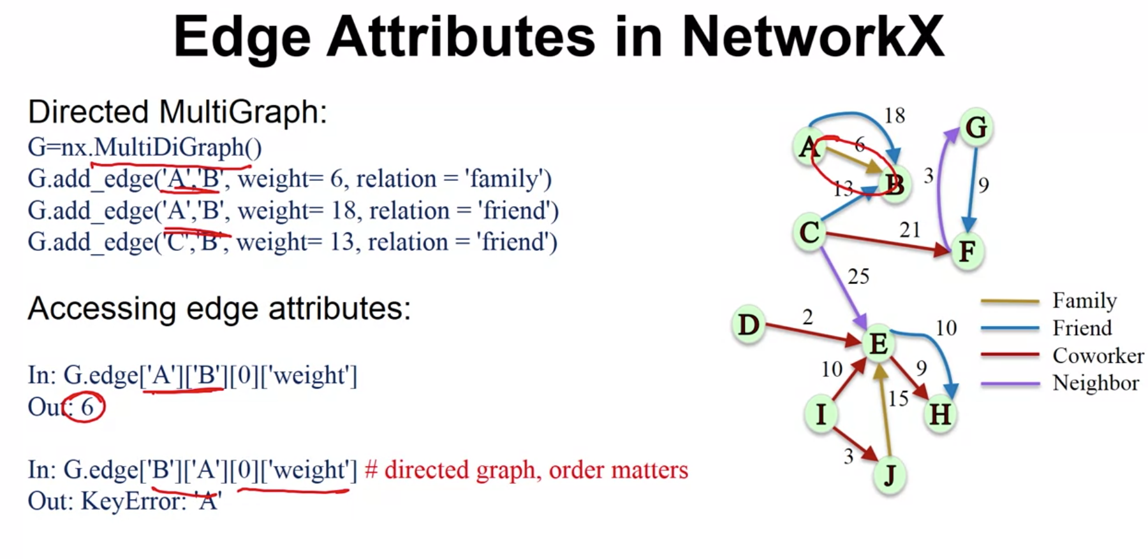

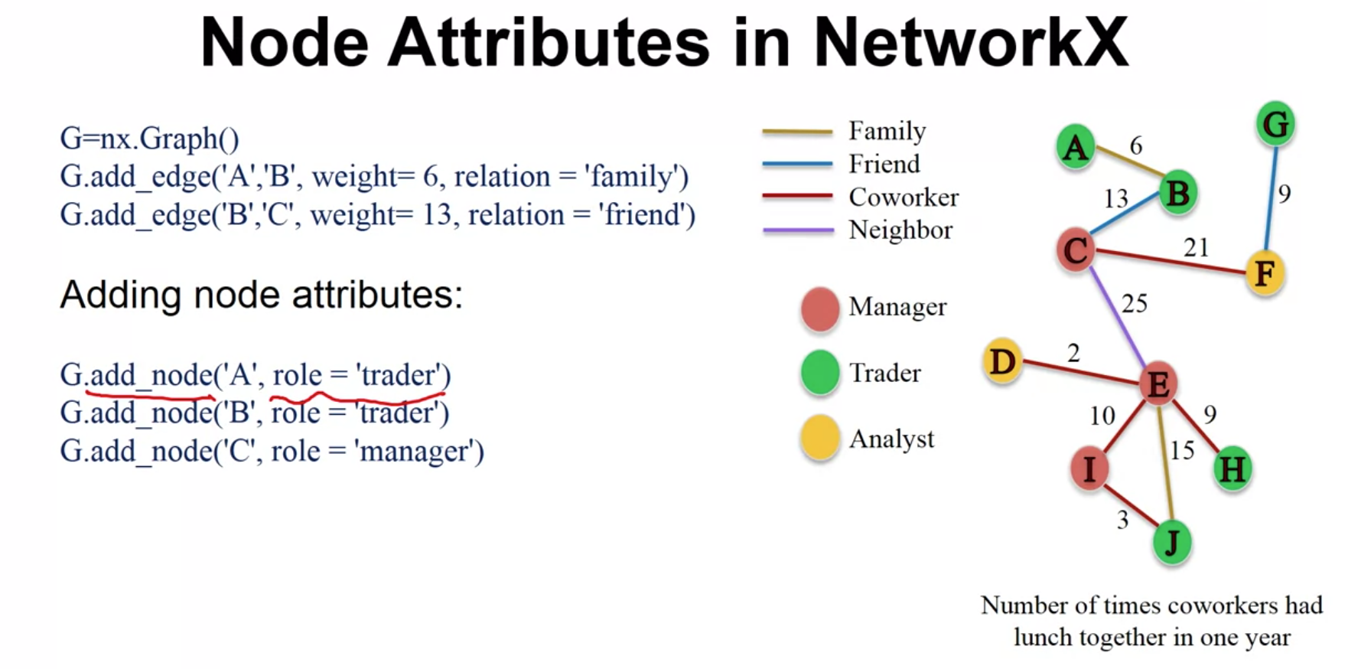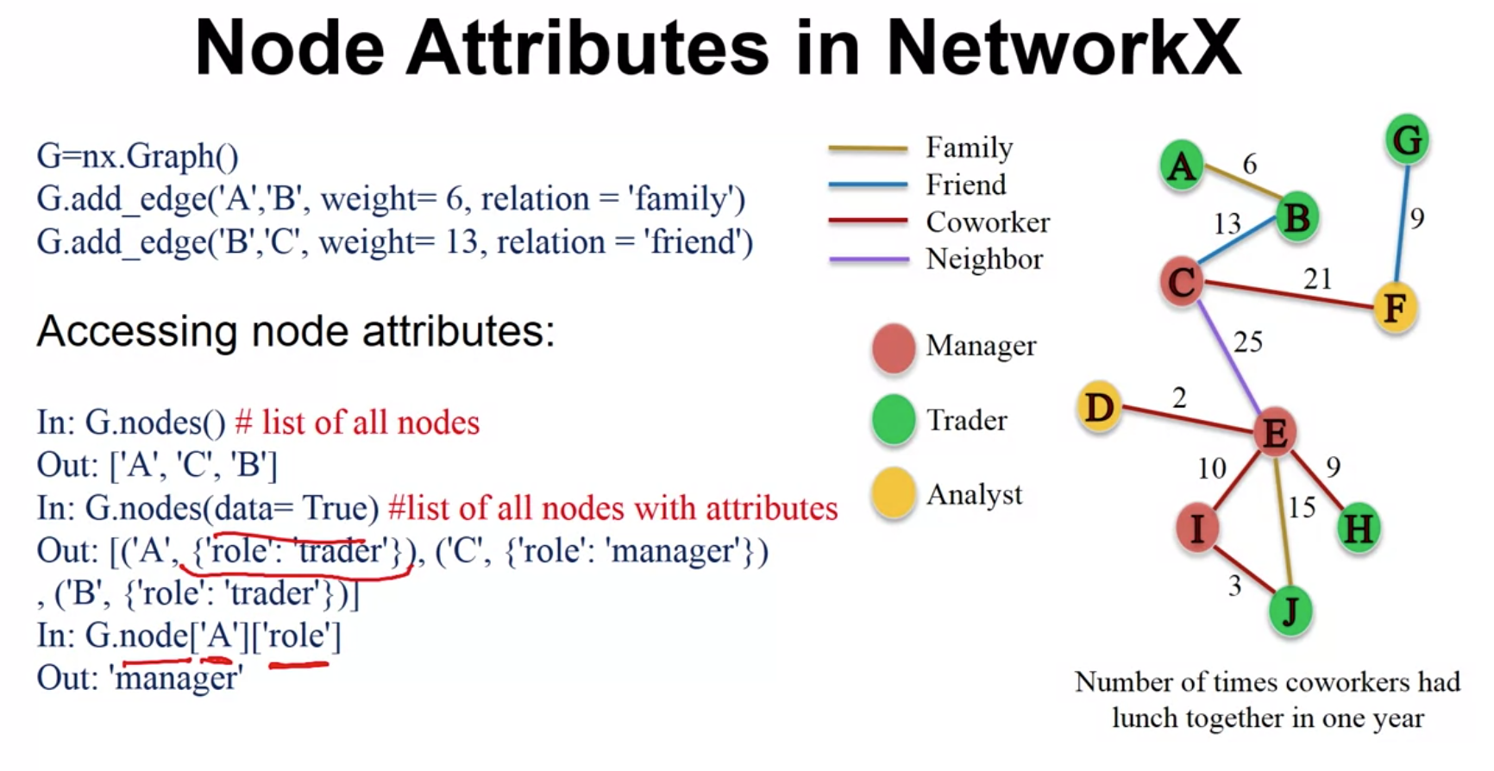

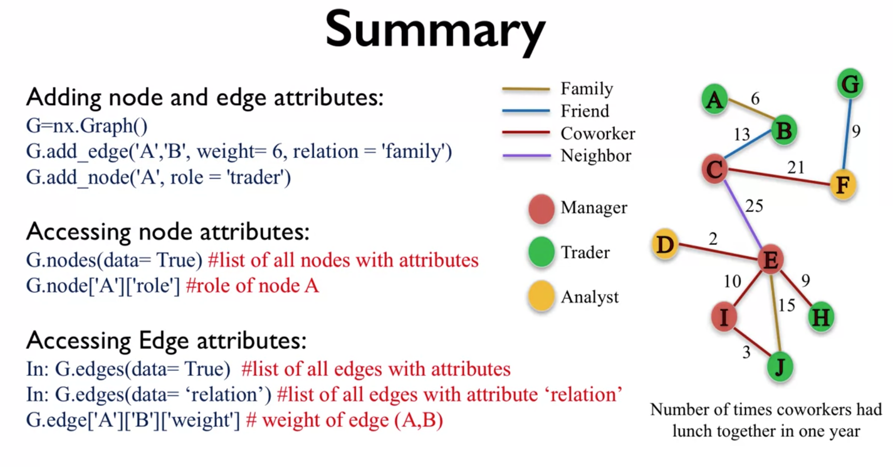

So in summary, in this lecture, we looked at how we add an access attributes for nodes, as well as edges. And depending on what we want, sometimes we want a list of all the edges, sometimes we're interested in a particular edge. Same thing for the node, sometimes we want to get a list of all the nodes, where there're attributes and sometimes we just want to get the attribute for a particular node.

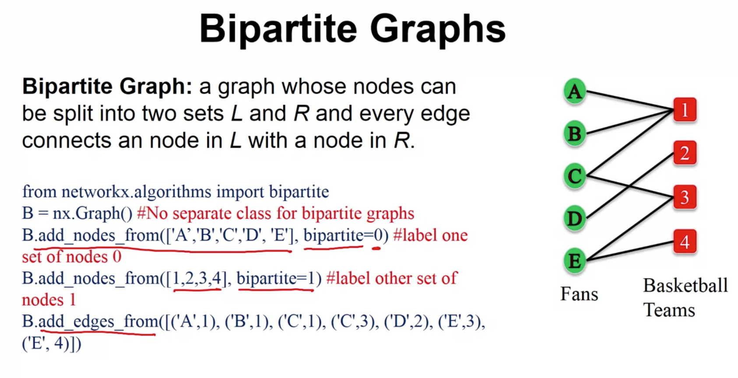

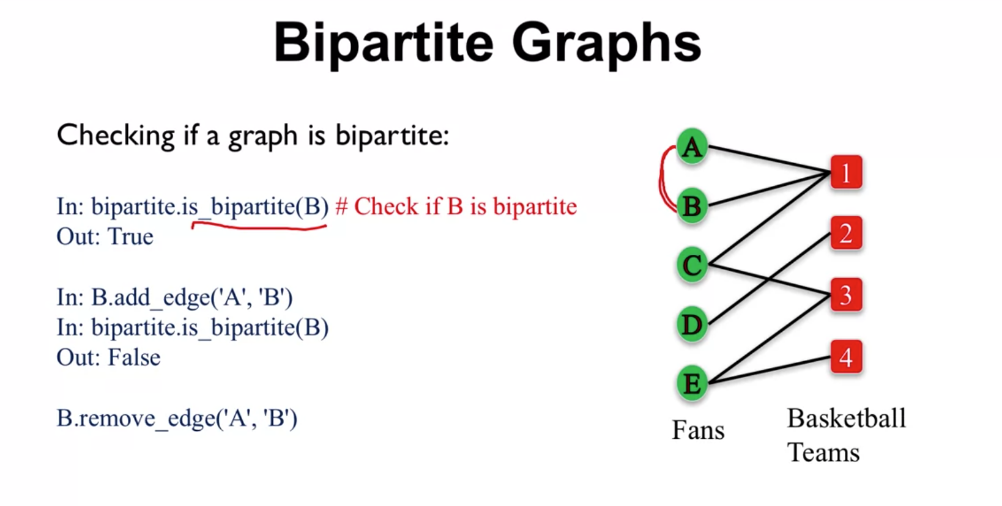

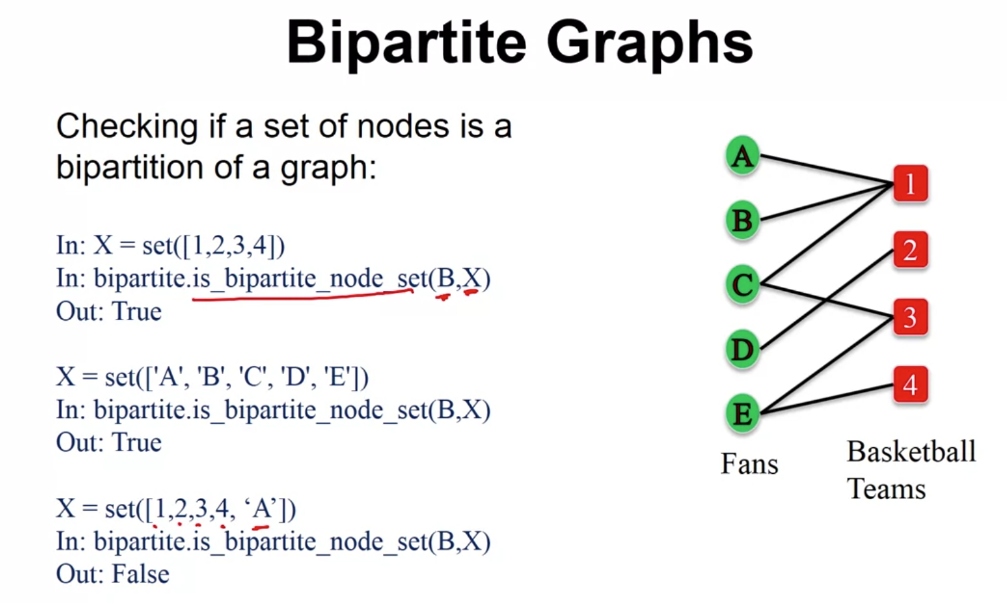

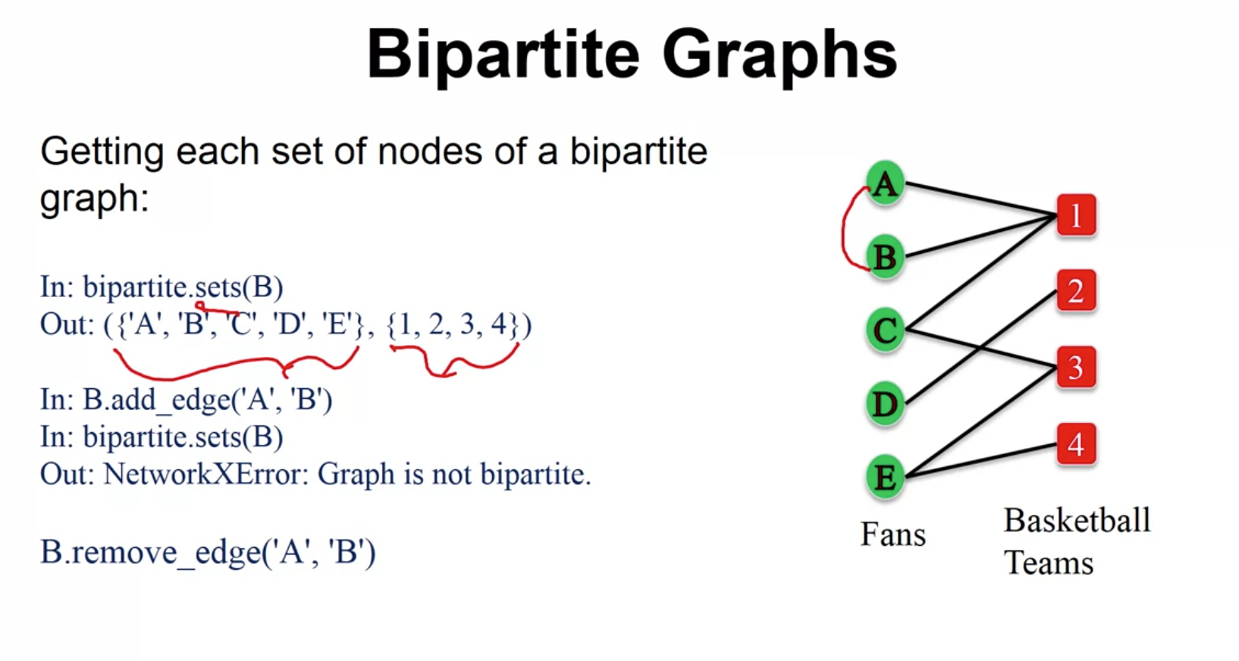

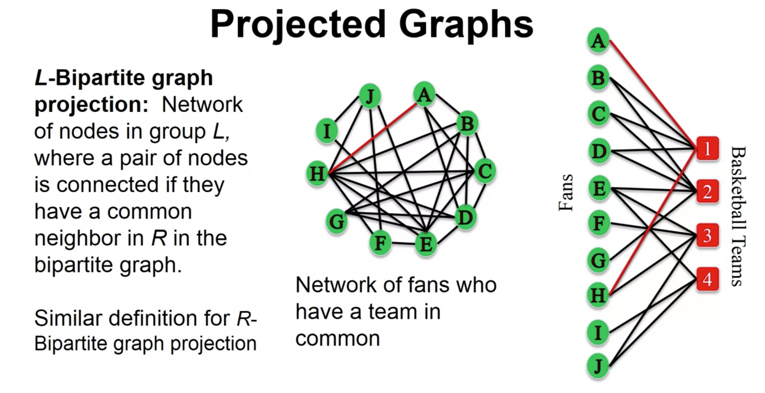

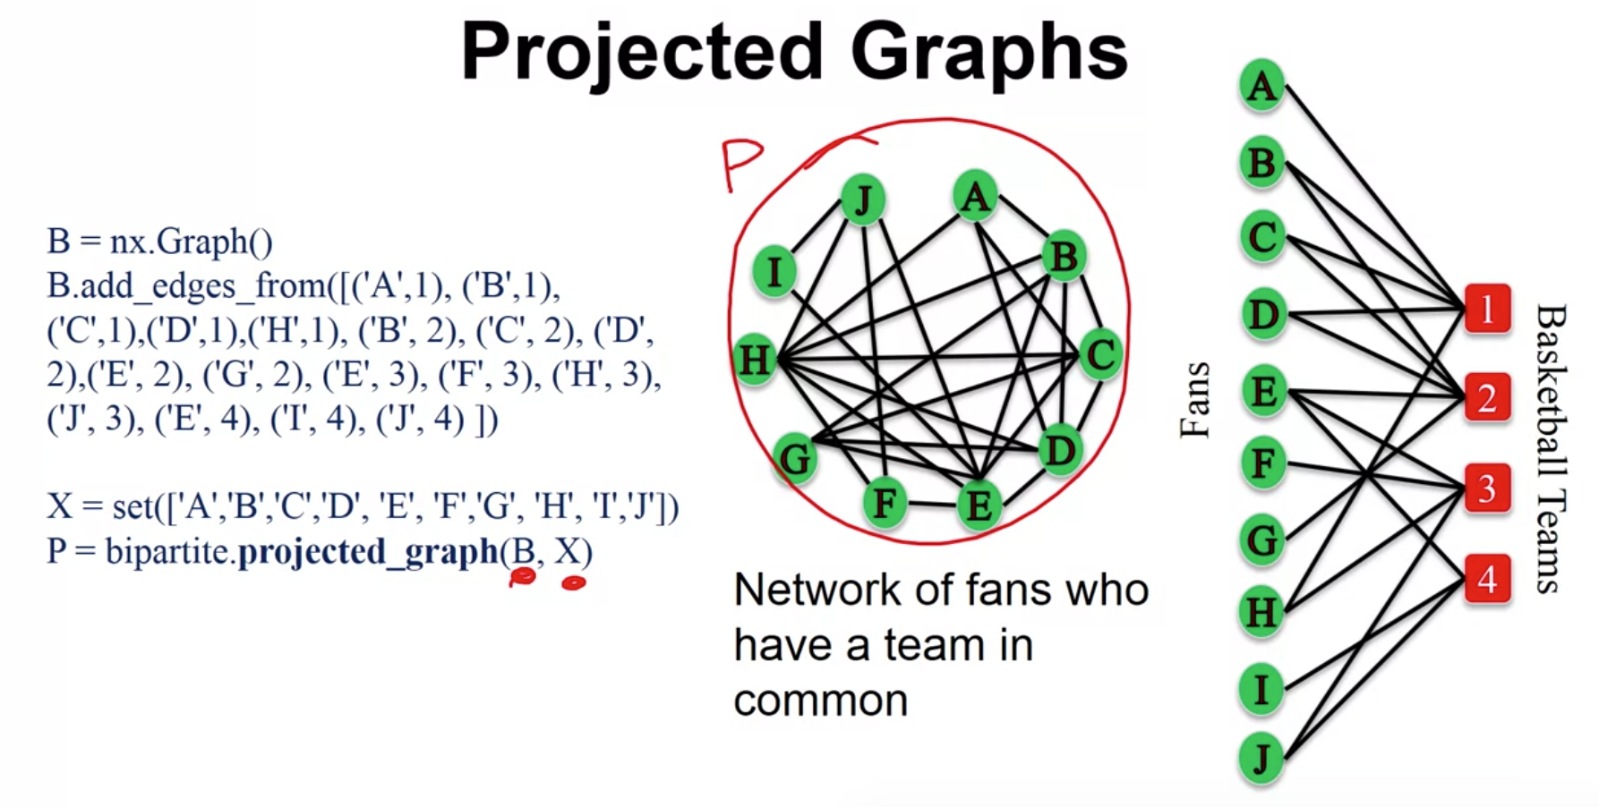

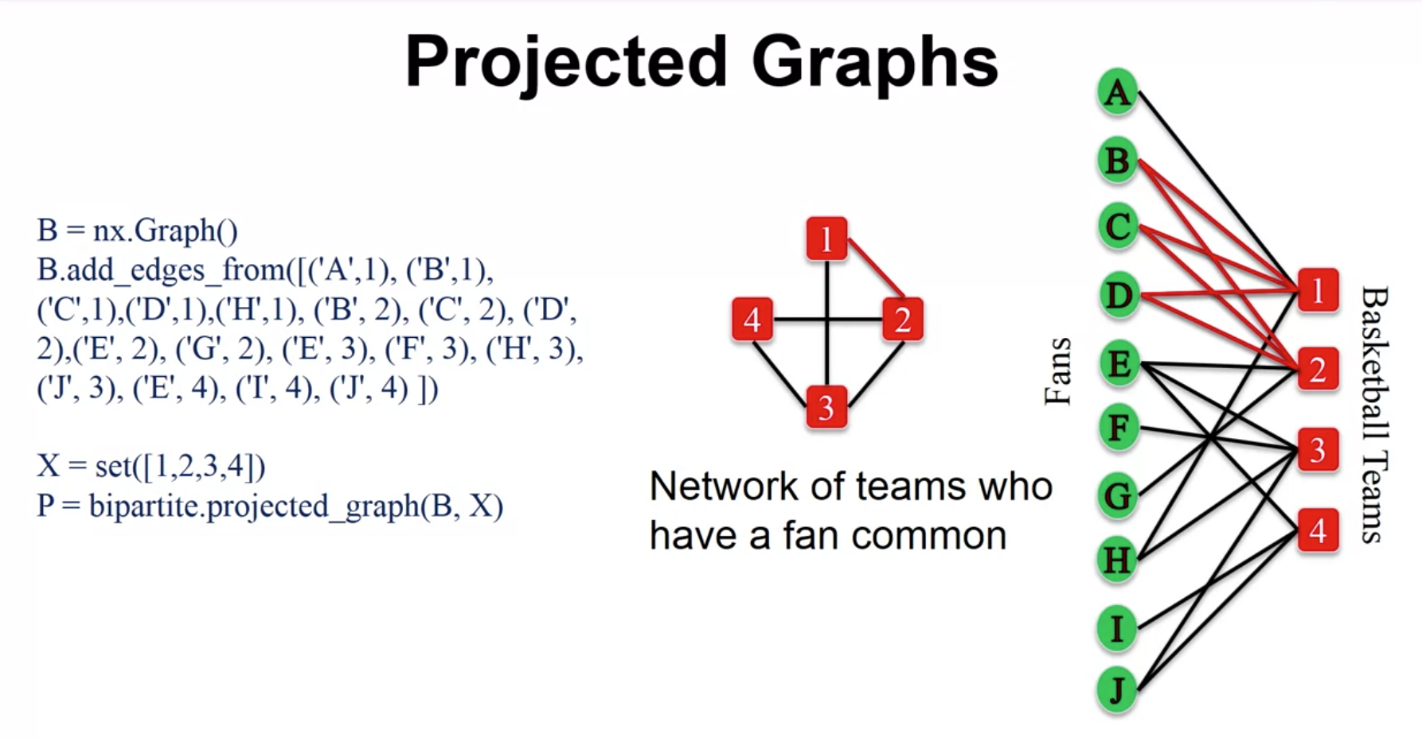

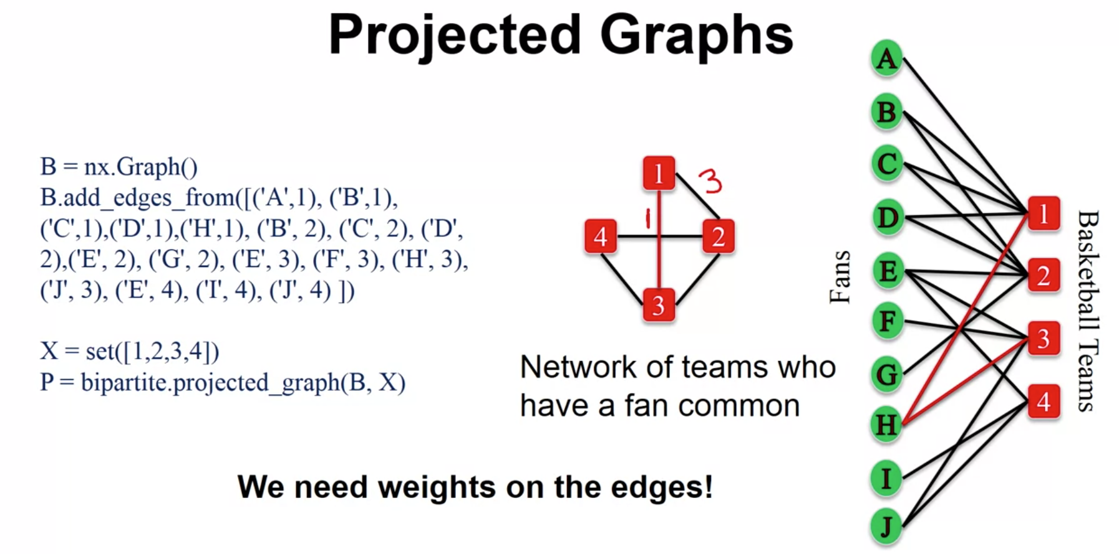

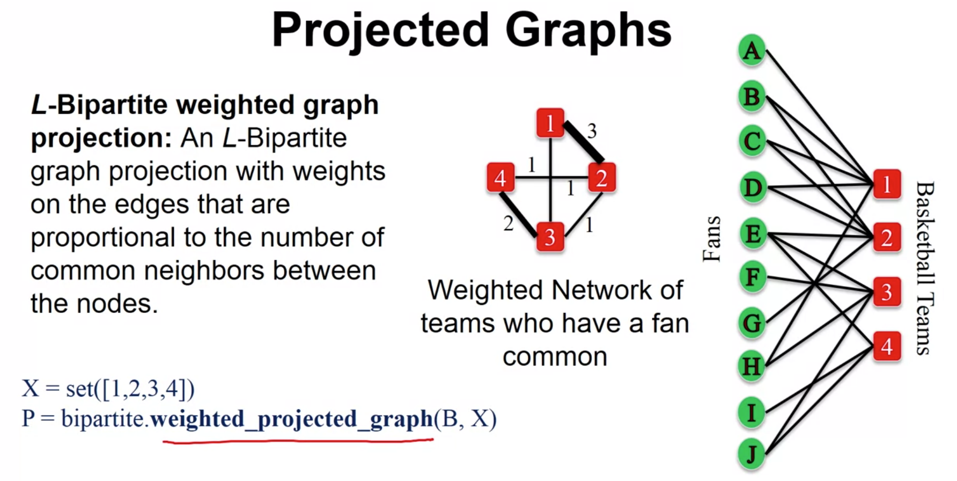

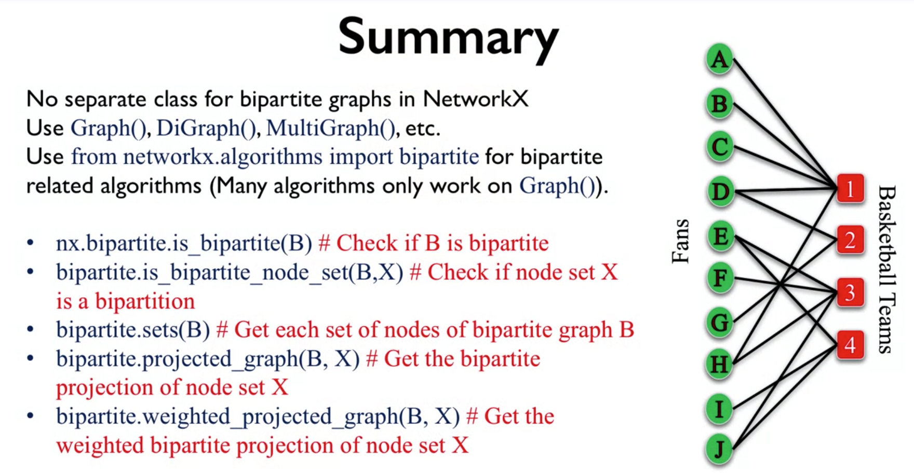

So in summary, in this video we've looked at bipartite graphs. The main thing is that, well the definition, right what it means. So, two sets of nodes and all the edges go from one side to the other and no edge goes from the set to itself.

And then to construct them on NetworkX, we're not going to use a separate class, we use the same classes that we already know, but rather we use a set of algorithms that allow us to do certain things for bipartite graphs.

Now, I will note that many of the algorithms that are available only work for the graph class, and so that's something you have to kind of be careful with. The kinds of things we looked at here, what you can do is you can check if a graph is bipartite.

You can check if set of nodes is bipartition of the graph. You can actually try to get the two bipartitions of the graph if the graph is bipartite, if not then you'll get an error. And we talked also about the projected graphs, which can be useful like in the case of the fans and basketball teams.

It would be useful to see what teams have fans in common and what fans have teams in common, and you can get these projections using NetworkX with the projected graph and the weighted projected graph which now adds not only an edge if the two teams have at least one fan in common but it actually captures how many. And this is the end of this lecture and I hope to see you in the next one.